## Bonus Problem – Cartesian Coordinate System

You are given a two-dimensional Cartesian coordinate system and the two coordinates (**X** and **Y**) of a point in the coordinate system. **X** and **Y** are non-zero numbers. If you don't know what Cartesian coordinate system is Google it with Bing. As you will find, the coordinate system is divided by 2 lines (see the picture bellow) which divide the plain in four parts. Each of these parts has a lot of points that are numbered between 0 and 3. There is one point where our lines are crossing. This point has the following coordinates: X=0 and Y=0. As a result this point is numbered 0 on the picture below.

Your task is to write a program that finds the number of the location of the given point in the coordinate system with **maximum 54 characters in your source code**.

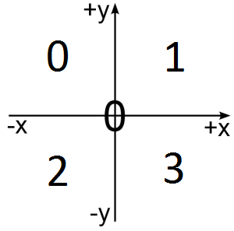

### Input

Input data is being read from the console.

The number **X** is on the first input line.

The number **Y** is on the second input line.

The input data will always be valid and in the format described. There is no need to check it explicitly.

### Output

The output data must be printed on the console.

On the only output line you must print an integer number between 0 and 3, depending on the location of the given point in the coordinate system.

Do not write new line on the final result.

### Constraints

* The numbers **X** and **Y** are non-zero numbers between -1 000 and 1 000, inclusive.
* Allowed source code length: 54 characters
* Allowed working time for your program: 0.10 seconds.
* Allowed memory: 16 MB.

### Examples

|  |  |
| --- | --- |
| **Input Example** | **Output Example** |
| -1  -2 | 2 |
| 1  -2 | 3 |
| -1  2 | 0 |
| 1  2 | 1 |